John-Joshua Izuegbu

Professor Zhang

CIS 3355

11/16/2020

1. Activity 10-1:
   1. Query the RPM database for Apache Web Server by typing rpm –q apache2 and pressing Enter from a command line prompt in the terminal window. You may have to be elevated to root to execute the command. Type su and enter the password to elevate to root. Write the command response in the space provided below.
      1. -apache2-2.4.43-lp152.2.6.1.x86_64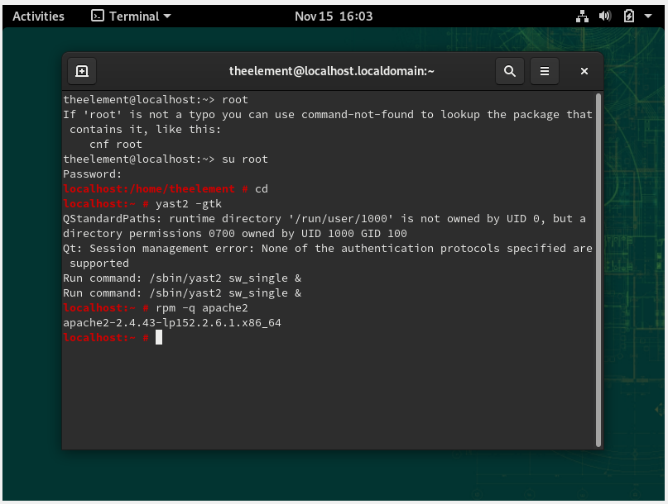
2. Activity 10-2:
   1. Verify that the server is running by opening a browser and typing http://localhost as the url you wish to navigate to. What response do you get?
      1. It works!
      2. 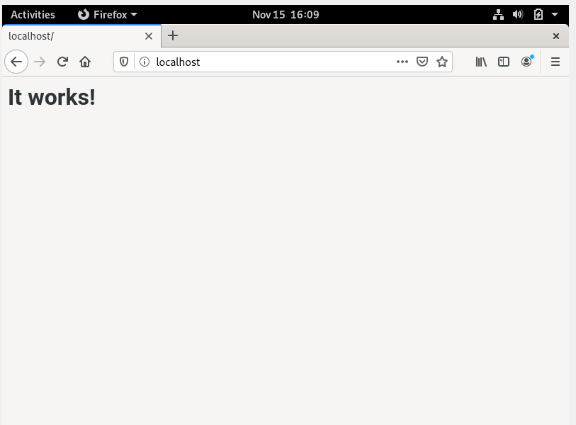
      3. 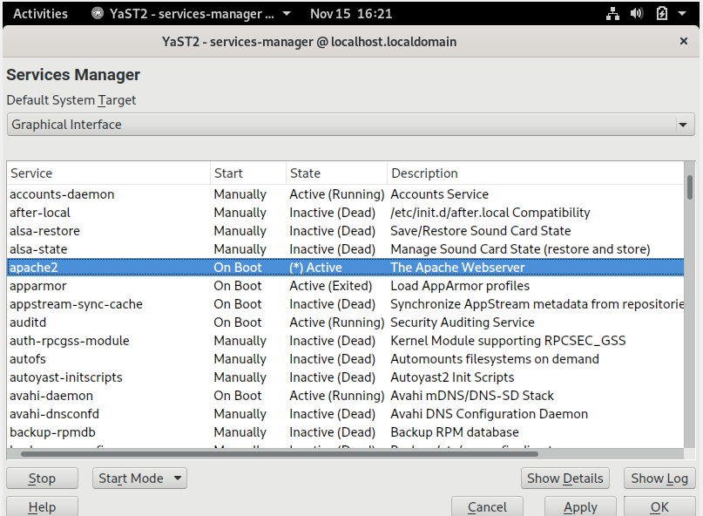
      4. Click Yes after you read the pop-up message from YaST. What does it say? After Clicking Yes, what does the new pop up say? Click OK to exit the Services Manager.Close YaST -It said do you want to save the changes made and start apache2.
      5. Test your Apache Web Server service by opening a Web browser such as Firefoxand typing http://localhost in the address bar. What is displayed in the browser window now? If you get an error message do not worry about it too much at this point as there will be more configuration steps in the next activity. 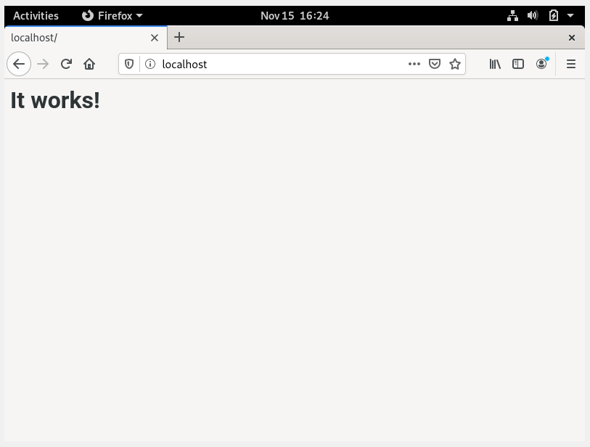
      6. “On Restart” 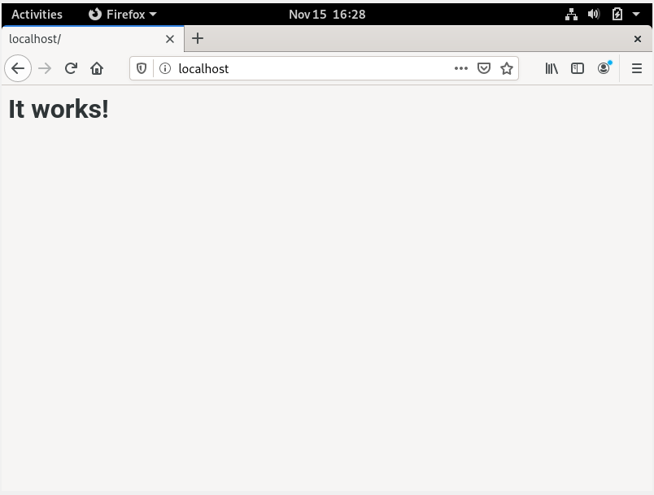
3. Activity 10-3:
   1. What is a port? Is it hardware? Software? Both? Find a description/definition and write it here.
      1. Port - a port is a logical construct that identifies a specific process or a type of network service. A port is identified for each transport protocol and address combination by a 16-bit unsigned number, known as the port number. The most common transport protocols that use port numbers are the Transmission Control Protocol (TCP) and the User Datagram Protocol (UDP). So a port can be a logical software array or it can be a physical medium.
   2. If the index.html file is not there, you will have to create it. See Figure 2 to see the code that should be in the default index.html file. If you don’t have an index.html file after installation, then create it using vim. Otherwise you will open it in vim. Once you have opened or created it and it is open in vim, make a change to the content so that your name will also be prominently displayed in the page when rendered in a browser. Save the file and then request the file from the Web server by typing http://localhost in Firefox again. You may have to refresh the page as the old index.html file may be cached. A sample of the type of change you should make and then be able to see is in Figure 3.

7d.Do you see the changes you made? Did you have to elevate to root user to change the index.html file? If you get an error message displayed from the web server, then reboot your VM and try again to view the index.html file in a browser. Sometimes rebooting is necessary to see server level changes.

* 1. 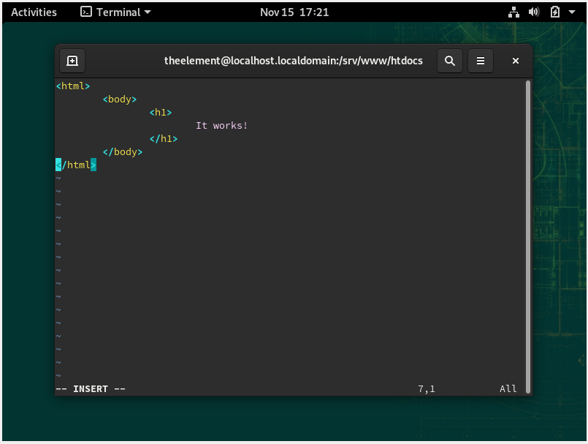
  2. 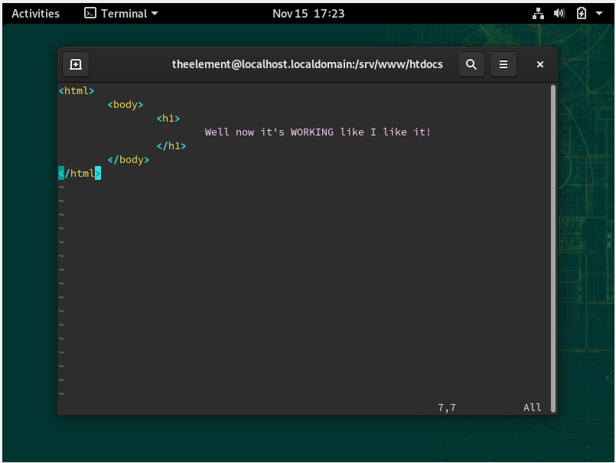
  3. 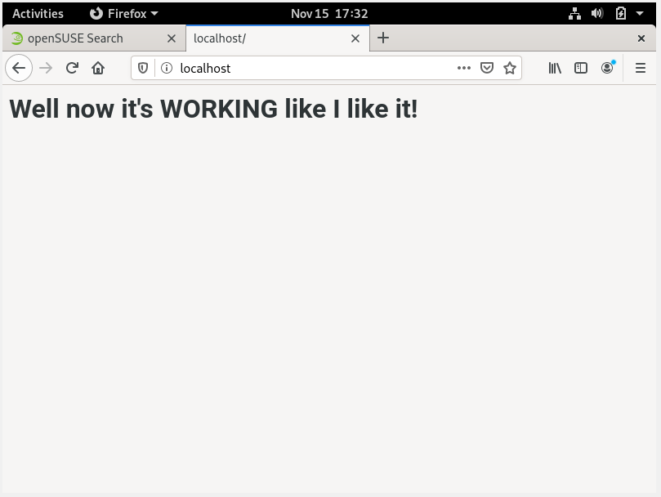

1. Activity 10-5:
   1. Start Firefox, type http://localhost in the address bar. What’s displayed? Next typehttp://yourfirstnamelastname in the address bar, and press Enter. What’s displayed?Next, type release notes in the address bar and press Enter. What’s displayed
      1. 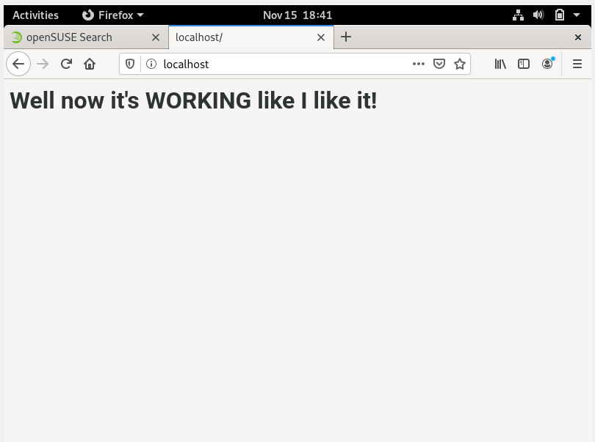
      2. 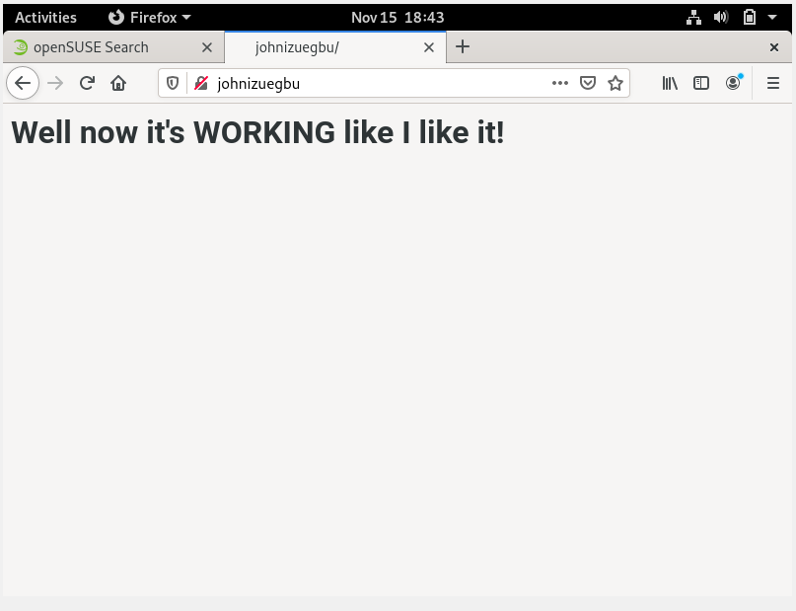
      3. 